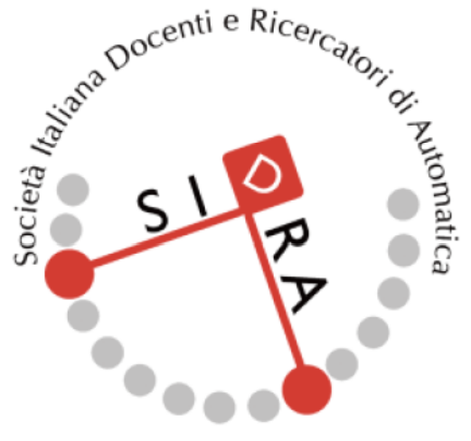 | SIDRA Annual Award for PhD Theses  in Systems and Control Engineering  Application form - 2025

I, the undersigned,
Last name:
Surname:
Place of birth:
Address:
Telephone and e-mail address:
ask for participation to the annual SIDRA Award for the best PhD Theses in the area of Systems and Control Engineering at an Italian University.
I declare that:
- I have completed my PhD program in:
- Title of the PhD program:
- University:
- Thesis title:
- Advisor:
- I have completed the final exam with favorable outcome on <date>
I attach, in electronic form:
  - Copy of the final version of the Thesis
  - Copy of the final assessment by the local Doctorate Committee after completion of the PhD program
  - An abstract of the Thesis summarizing its innovative aspects, main results, theoretical contributions, and possible applications (maximum 2 page A4, format pdf, line spacing 1.5, character size 12)
  - A recommendation letter by the thesis Advisor
    - assessing the quality of the dissertation in terms of its scientific relevance, and
    - underlining the reasons why the thesis deserves the award
Date: Signature:

